**Decisions**

**These are the decisions and rules we made in our traffic simulation system**

1. **Crossing**
2. **We use two types of Traffic system**
3. **Type One- this crossing have no pedestrians**
4. **Type two –has crossing with pedestrians**
5. **Both the Crossings have 12 lanes**
6. **Each Lane have One direction**
7. **Each Lane have one Light**
8. **The Lanes have Numbers to identify them (L1,L2,…L8) as you can see it from figure below**
9. **Type two crossing have two extra lane**

**Crossing Type I**

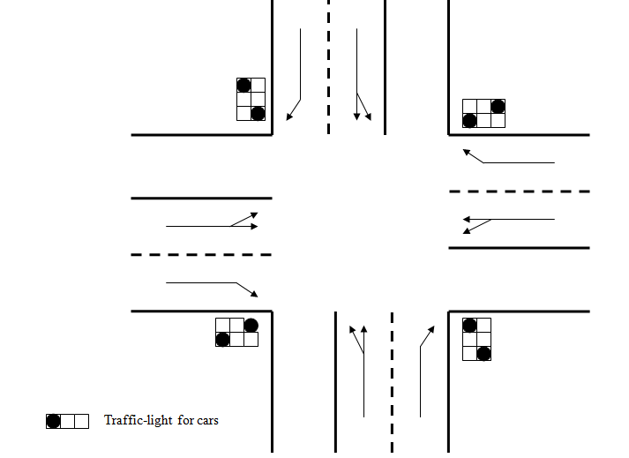

**L12**

**L11**

**L10**

**L9**

**L8**

**L7**

**L6**

**L5**

**L4**

**L3**

**L2**

**L1**

1. **Same green Lighting System groups**
2. **L1+L2+L8+L9 group-1**
3. **L5+L6+L10+L11 group-2**
4. **L12+L4+L1 group-3**
5. **L3+L7+L6 group-4**
6. **Lighting Shift**

**The sequence of green lighting in group will be first Group-1, then Group-2, later Group-3, finally Group-4, and It will go back again to group1 in cycle.**

**Crossing Type-II systems**

1. **These system have extra pedestrian lights at lane 1+lane2 and lane5 + lane6**
2. **The green timing of pedestrians will be accompanied with some car green light**

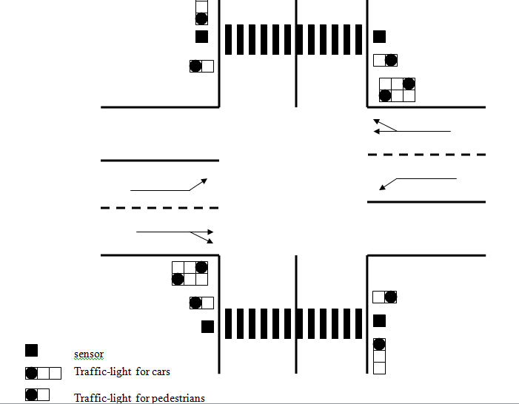

L3

L2

L1

L12

**Pedlane 2**

**Pedlane** 1

L10

L11

L4

L5

L6

L7

L8

L9

1. **Same green Lighting System groups**

**L1+L2+L8+L9 group-1**

**L5+L6+L10+L11 group-2**

**L12+L4+L1 group-3**

**L3+L7+L6 group-4**

**L5+L11+Pedestrain-1+ pedestrian-2 group-5**

1. **Sequence of light green**

**The sequence of green lighting in group will be first Group-1, then Group-2, later Group-3, Group-4, finally Group5 and It will go back again to group1 in cycle.**

**NOTE- When shifting green lights from one group to the other, if the same lanes exist in the next group as the previous one, the light keeps being green without being red. It means they have longer length than others.**

**Default Values**

**When Adding a crossing to the project for first time the system will give default values of number of cars, green time for each light**

* **The Number of cars in each lane at the beginning is 20 cars for each lane**
* **The green timing for each light will be equal and it is 20 sec**
* **The Ratio of cars in the three Lanes of same road will be 1:2 for first lane and second lane, and the remaining car will be for the third lane**

**Traffic Jam**

**Traffic jam will be for each lane and it is maximum cars stopped in a lane.**

**The traffic jam will be calculated by the crossing considering the time and number of cars in lanes.**

**The number of cars stopped in lane should not be more than the number of maximum capacity of lanes, otherwise it means that lot of cars are piling up in the lane beyond the limit because cars are not removed from lane(the light is long red or short green).**

**Some Changes in UID**

